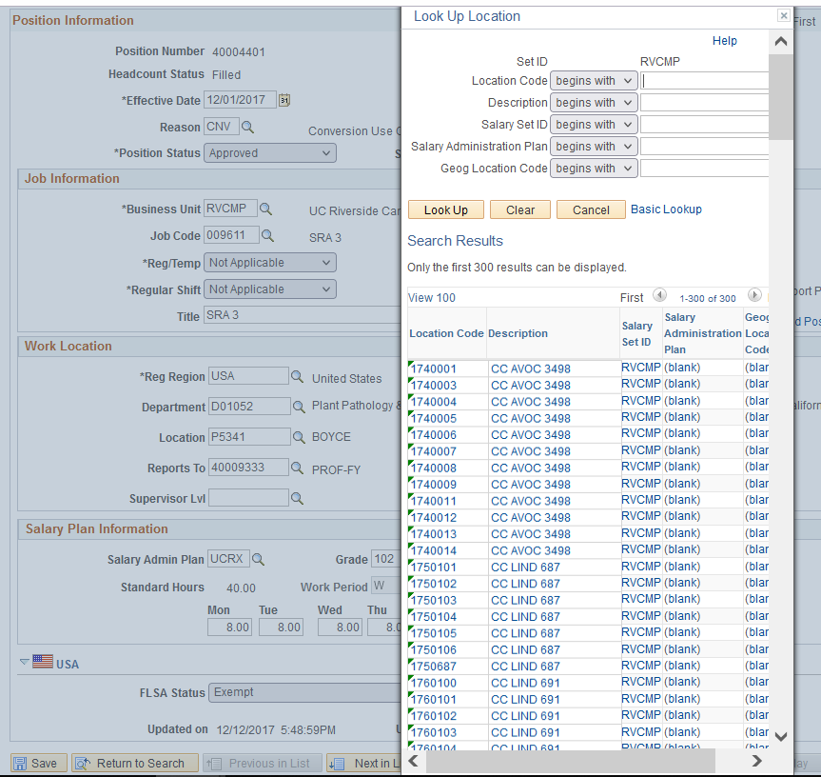
PHASE I: AB119 System & Data Update
November 9th
Location Data will look different in UCPath beginning November 9th
- Pending UCPC configuration update
- Location lookup tables will contain the new format for the location code
November 9th – December 13th
The Location Data for existing positions will be managed centrally by CSC during this period
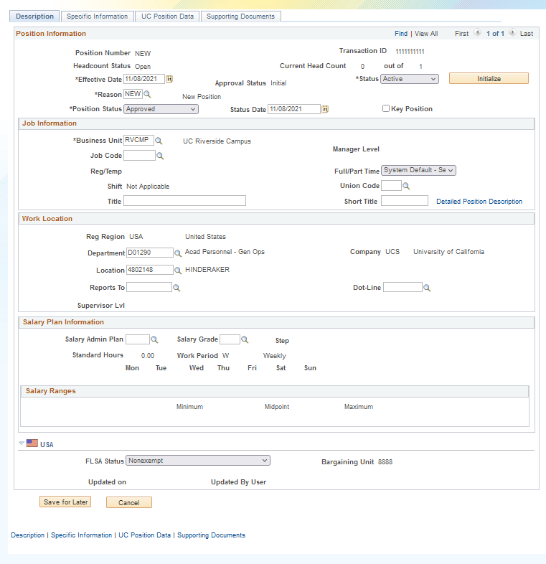
- SSC Transactors will need to utilize the default location value that populates when the department is entered for new positions or position transfers during this period
- Reach out to kameron.johnson@ucr.edu for any departments without default values
- Updates to existing positions will be handled through a collection process between CSC and the SSCs during this period
PHASE II: AB119 Compliance Rollout
December 13th forward
The management of location data will be rolled out to the campus

