Student employees are assigned student UCR NetID’s prior to being hired as a paid employee or volunteer (Contingent Worker). The UCPath employee ID and Student NetID must be reconciled to form the UCR identity profile that allows them access to UCPath and several local systems such as Timesheet (TARS), LMS and other local systems as provisioned.

The UCPath-Banner Match program uses one of 4 values to verify a student’s identity and match the employee ID (EMPLID) and the student NetID:

1. Social Security or National ID (must be in both UCPath and Banner)
2. Student ID
3. Student NetID
4. UNEX NetID

The Student ID, Student NetID or UNEX NetID must be provided to the Shared Service Center to be entered into the External System field of the Onboarding template. This information cannot be added after UCPath has processed the template.

Matching data points include:

SSN  
(must be in UCPath and Banner)

Student NetID

Student ID

UNEX NetID

OR

OR

OR

The SSC selects the External System value from the drop-down menu. Then enters the provided value into the UC External System ID field in the SMART HR Template.

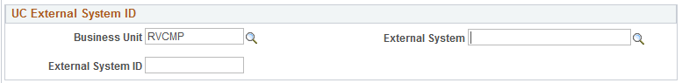

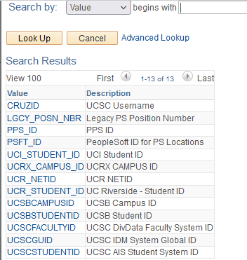

The student employee will then be able to log into UCPath and the other local systems within 24 hours of UCPath processing the template.