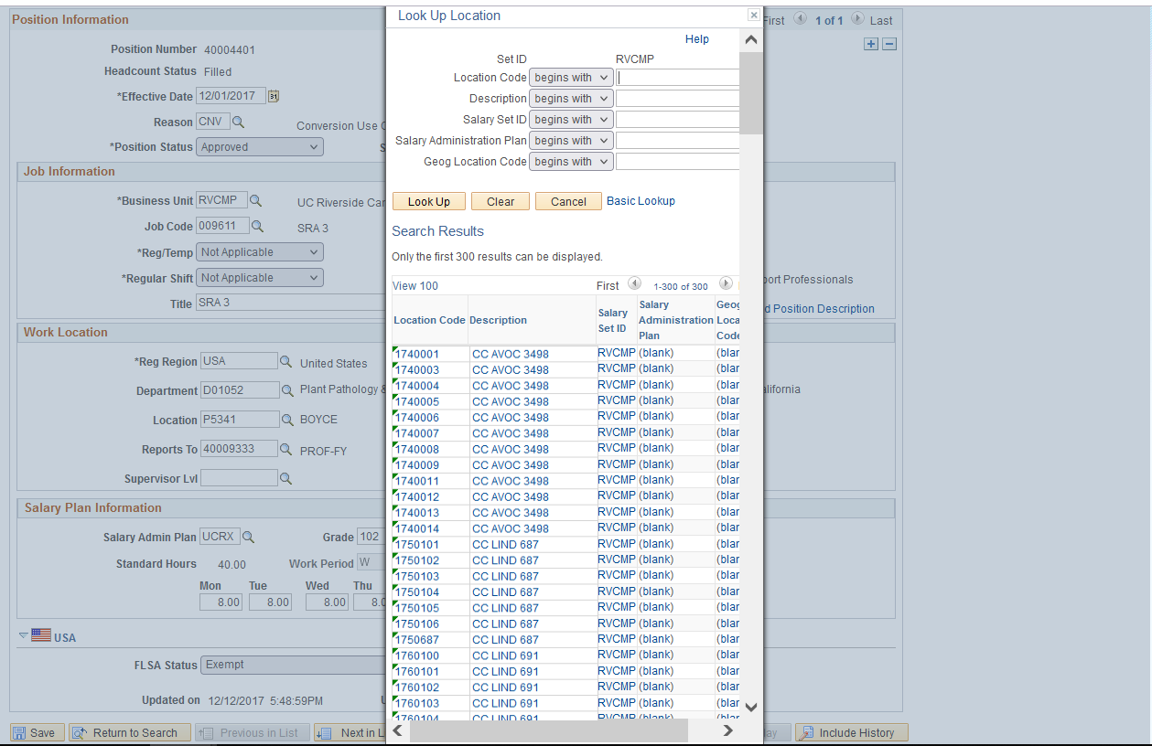

**PHASE I: AB119 System & Data Update**

**November 9th**

Location Data will ***look different*** in UCPath beginning November 9th

* Pending UCPC configuration update
* Location lookup tables will contain the new format for the location code

**November 9th – December 13th**

The Location Data for existing positions will be ***managed centrally*** by CSC during this period

* 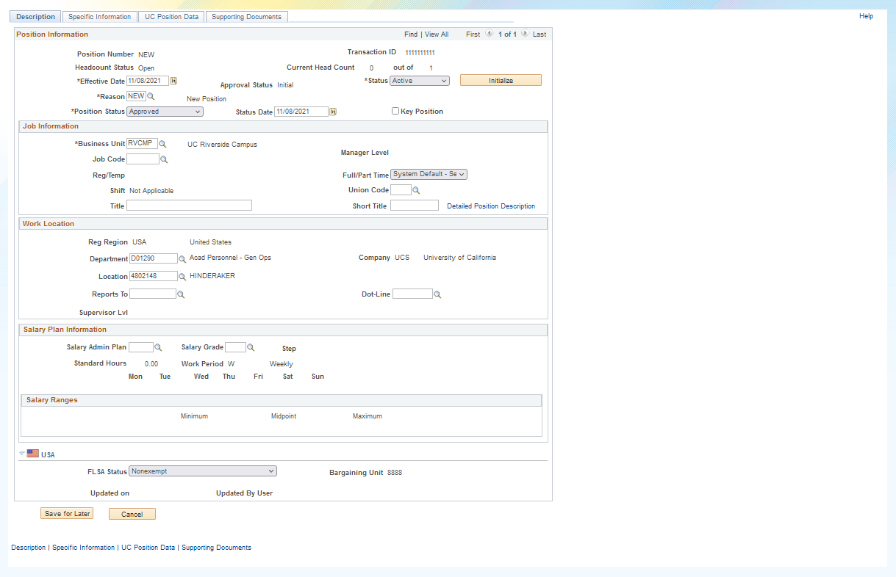SSC Transactors will need to utilize the ***default location value*** that populates when the department is entered for new positions or position transfers during this period
* Reach out to [kameron.johnson@ucr.edu](mailto:kameron.johnson@ucr.edu) for any departments without default values
* Updates to existing positions will be handled through a collection process between CSC and the SSCs during this period

**PHASE II: AB119 Compliance Rollout**

**December 13th forward**

The ***management of location data*** will be rolled out to the campus